contact-manager
⁂This Python Contact Manager stores contacts in a dictionary and lets users add, remove, block, activate, favorite, and search them. Each contact saves phone number, status, and last edited time using the datetime module. A menu-driven loop handles user choices and displays all saved contacts, updating details whenever changes are made.
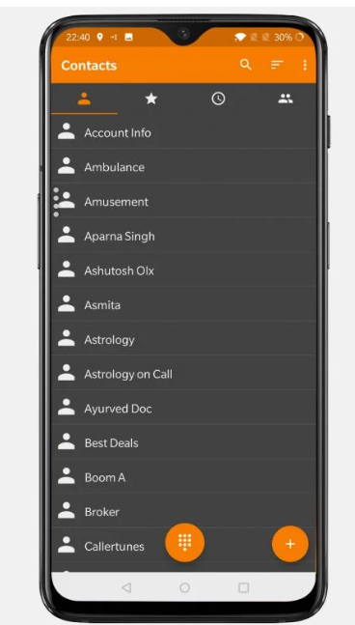
⁂Objective: To design a simple contact management system using Python.To implement CRUD (Create, Read, Update, Delete) operations.To maintain contact details in a structured dictionary. To allow users to interact with the program through a menu-driven system.To track updates by storing the last edited time of each contact
⁂The project requires Python 3.x software to run the program and any basic system or mobile device capable of executing Python code. Users should have basic knowledge of Python, including functions, loops, and dictionaries, to understand
⁂Functional Requirements
Add new contact
Remove existing contact
Block/unblock contact
Mark contact as favorite
Search contact details
View all contacts
Record the last edited time
Exit the program

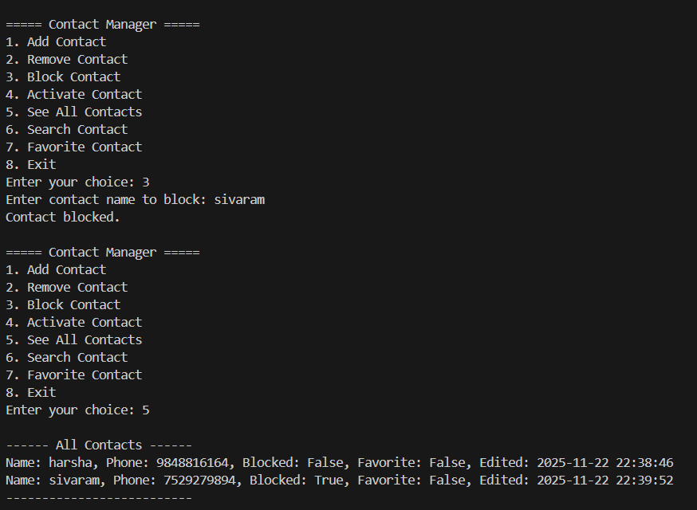
Output of my project:
